Appetito Restaurant – Project Report
Name: Ali Nehme
Student ID: 12510101

1. Introduction
This report presents the Appetito Restaurant web application developed using ReactJS. The project includes multiple pages, responsive design, and a functional Cart system.

2. Technologies Used
- ReactJS
- Vite
- JavaScript ES6+
- CSS
- LocalStorage
- VS Code

3. Screenshots
Screenshot: D9D43583-2FA4-4946-8BB0-9F6EEEA7AB7A.jpeg
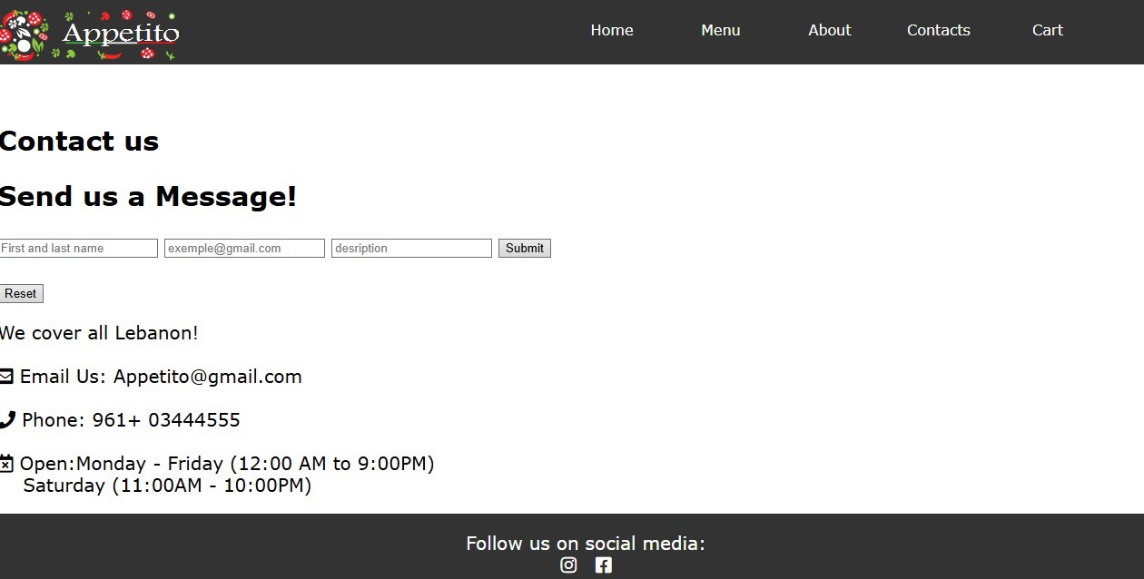
Screenshot: 819EEC4A-1F84-4514-8103-24204B2D31E6.jpeg
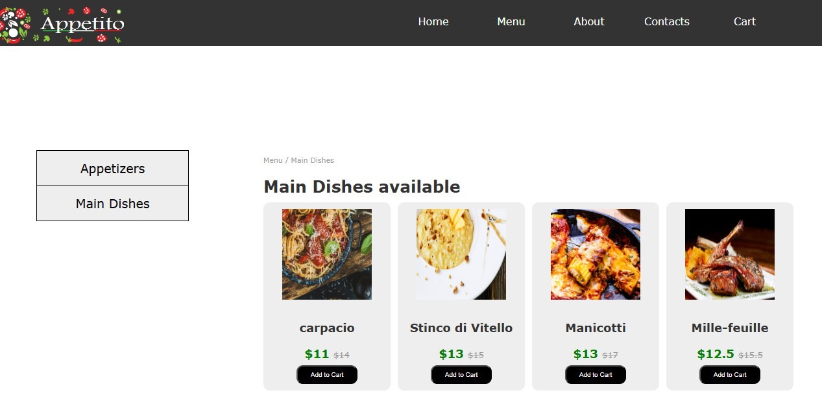
Screenshot: 96472F7B-702F-4A3E-B405-33171823D529.jpeg
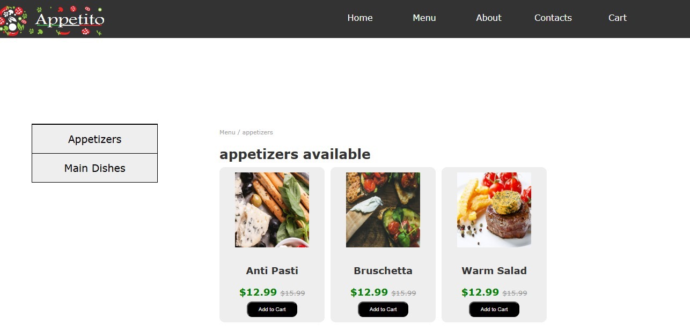
Screenshot: 67020755-FB75-487B-B8CB-6E63E2544F44.jpeg
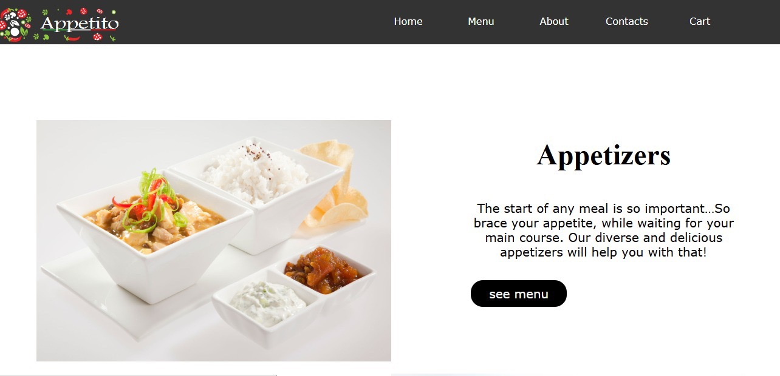
Screenshot: 242E50BF-6008-4982-9C1C-AD9721F10288.jpeg
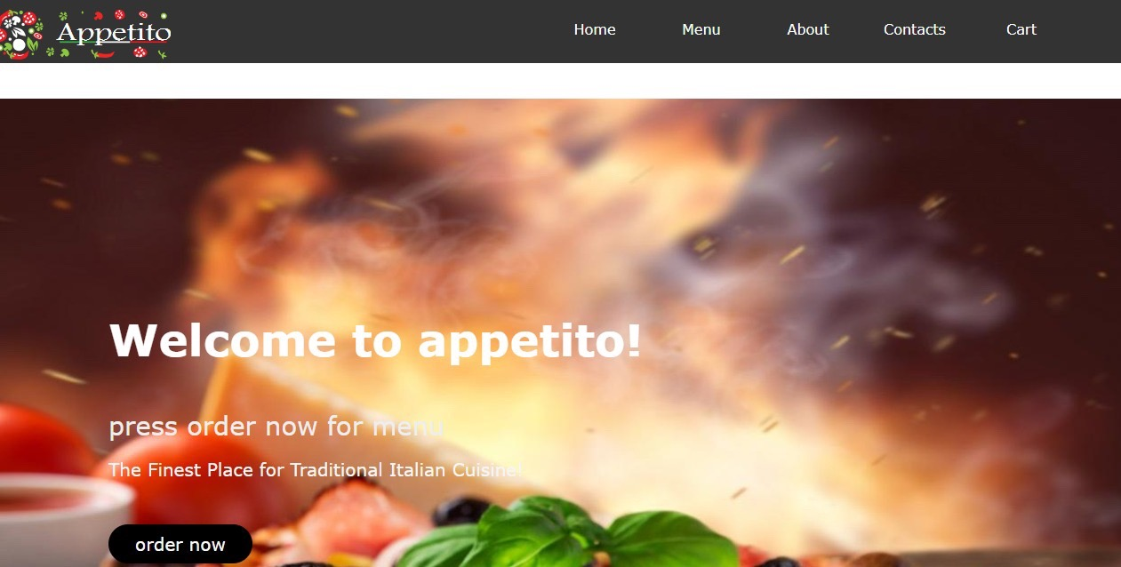
Screenshot: 62826094-0D69-4FB1-B93A-6CC90248F7F4.jpeg
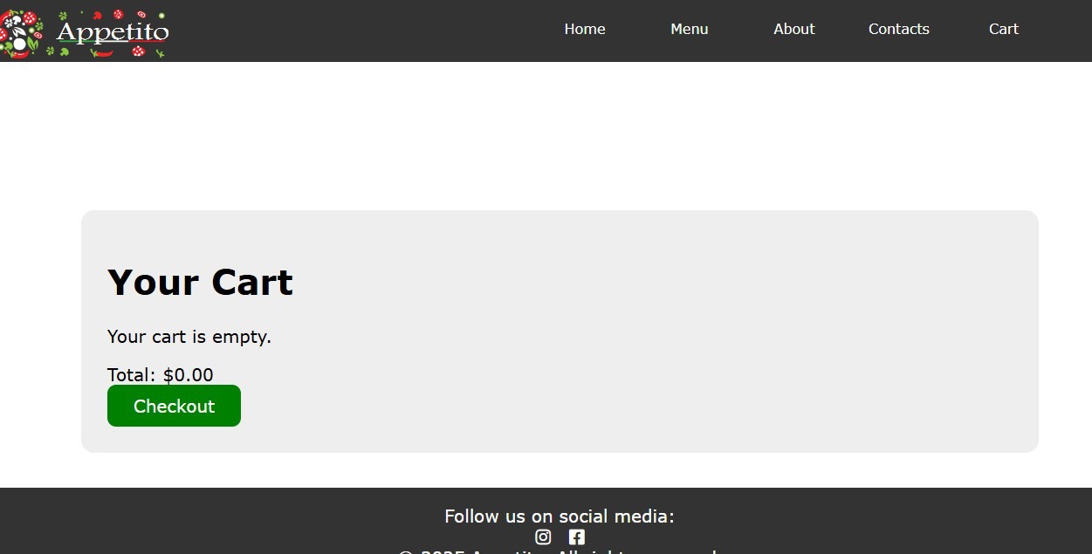

4. Conclusion
The Appetito application meets all requirements for the course project. It demonstrates ReactJS components, routing, state management, and responsive UI design.

